**"Don't Junk-it List-it"   
Unit Testing Document**

**Submitted to: Clarkton Corporation**

**Unit Testing:**

* **Login Page:**

1. **Successful Authentication**: Upon entering valid credentials, the user will be seamlessly redirected to the homepage without an intermediate success message.
2. **Authentication Failure**: If invalid credentials are provided, an error message will be displayed to inform the user of the unsuccessful login attempt.

* **Signup Page:**
  1. **User Registration Validation Test:**
     + Conduct thorough testing of the user registration process to confirm that new users are correctly added to the database upon completion of the registration form with valid information.

**Outcome:**

Successful registrations are immediately reflected in the database update.

* 1. **Incomplete or Invalid Registration Attempt:**
     + The system must validate input fields and reject registrations that contain incomplete or invalid information. For instance, if the username field is left empty, the system should respond with a validation error: "User validation failed: username: Path **username** is required."
     + Real-time feedback should be provided to indicate whether the password criteria have been met or if there is a mismatch during the registration process.

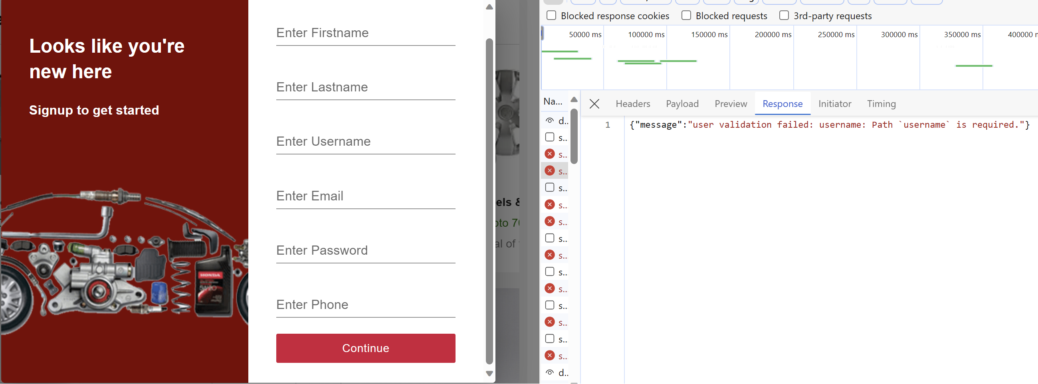

* Categories:

**Category Retrieval Function Test:**

Evaluate the functionality responsible for fetching and presenting the complete list of available categories to ensure it operates as intended.

**Expected Result:**

The system should accurately display all categories that are currently available within the platform’s database.

* **Listing:**

**Listing Item for Sale Test:**

* + - Objective: Assess the functionality that enables sellers to list an item for sale, ensuring the item is properly added to the database.

**Outcome:**

* + - Confirmation that upon listing, the item is successfully recorded in the database.

* **Cart Update Test:**

**Objective:**

* + Evaluate the functionality that allows users to add items to their shopping cart, verifying that the cart updates accurately.

**Outcome:**

* + The cart reflects the correct items and quantities after an item is added, confirming the update is functioning as expected.

* **Seller Posting Test:**

**Objective:** To assess the process through which sellers post items for sale, ensuring the posting mechanism operates correctly and efficiently.

**Outcome:**

New listings should appear in the marketplace without delay, and be visible to potential buyers with all the provided details correctly displayed.

**2. Integration Testing**

**Objective:** Examine the seamless operation between the Login and Signup Pages by conducting tests on user registration followed by a login procedure with the newly created credentials.

**Outcome:** The integration functions correctly, with successful registration leading to an immediate ability to log in using the new account details.

**3. System Testing**

* **User Journey Test**

**Objective:** Test the entire system workflow, encompassing the steps from user registration to final payment.

**Outcome:** All components of the user journey, including signup, login, listing, category approval, purchasing, and payment notifications, are verified and functioning as expected.

* **System Responsiveness Test**

**Objective:** Assess the system’s performance across various devices and web browsers to ensure responsive design.

**Outcome:** The system is responsive and fully operational across different PCs, with users successfully completing registration, item listings, and purchases.

**4. Functional Testing**

* **Individual Functionality Test**

**Objective:** Rigorously test each feature including the Login Page, Signup Page, Categories, List Item for Sale, Cart, and Payment processes to confirm they adhere to the defined functional requirements.

**Outcome:** All tested functionalities meet or exceed the specified requirements, indicating full compliance with the functional specifications.

* **Permission-Based Behavior Test**

**Objective:** Verify that the system's behavior aligns with expected outcomes when users engage in actions within their granted permissions.

**Outcome:** The system operates within expected parameters, allowing user actions that are within their set permissions without issue.

* **Access Restriction Test**

**Objective:** Validate that the application restricts access as designed when simulated attempts are made to breach accessibility guidelines.

**Scenario:** A user attempts to purchase an item they have listed for sale.

**Result:** The system correctly prevents the user from buying their own listed item, upholding the designed access limitations.